How does detoxing work?

A detox is simply a way of cleansing the blood and liver so the toxins inside your body are removed and your clean blood brings more oxygen to your organs. The cleaner your blood, the healthier your whole circulatory system will be. The body also needs to eliminate toxins from the liver, intestines, skin, kidneys, and lungs. Removing the toxins is the first step to reaching maximum health.

Remember, toxins are everywhere. I encourage you to reduce toxic load whenever you can. Make self-care your priority and start making some lifestyle changes, such as; switching out your harsh cleaning supplies and cosmetics, eliminating processed foods that are essentially dead foods, and create a routine each evening to help your mind wind down so you can sleep peacefully.

You might be surprised to know that many common foods can be triggers for allergies, digestive upset and skin irritations. The 2 Day Cleanse eliminates common triggers. You won’t find any dairy, nuts, soy, eggs, alcohol or caffeine on your meal plan. You’re giving your body a little break from foods you may not even realize are causing you problems.

You can add high quality animal proteins and grains if you like.

I believe that superior nutrition, restorative sleep, sparkling clean water, and wonderful friends that fill your days with laughter and support are the keys to well-being.

If you decide to use essential oils in your recipes, please be aware that not all essential oils are safe to ingest. Not every essential oil company makes oils that are safe to ingest. doTERRA sells certified pure, therapeutic grade oils that are safe to ingest. If you do not have a doTERRA wholesale membership, you can use my web site to order oils at retail. Please go to www.mydoterra.com/wendysays.

I would love to hear from you. If you have a question about a recipe, want to learn about the two week Spring Detox, would like to get a wholesale membership with doTERRA or you would like to get together for tea, please call me at 808.269.9373.

I look forward to supporting you in this divine journey and remember to take a deep breath and know this journey is to release what does not serve you.

Much love,

Wendy

2 DAY CLEANSE

LEMON WATER ELIXIR
Serves 1
1 cup room temperature water
juice of 1 lemon or 10 drops of Lemon essential oil
1 tablespoon Bragg’s raw apple cider vinegar
1 teaspoon raw honey, maple syrup, or stevia to taste (optional)
dash sea salt

*NOTE: If you feel nauseous or experience tightness in the chest after drinking the Elixir, please omit the raw apple cider vinegar. This reaction may occur when the body releases bacteria and toxins during cleanse. Continue to drink the Lemon Water Elixir using only ½ teaspoon of apple cider vinegar OR omit it completely for the next three days. After 3 days is over, try the Elixir again with the full amount of the apple cider vinegar. If the reactions continue, then only drink the lemon water.

Day 1

BREAKFAST-
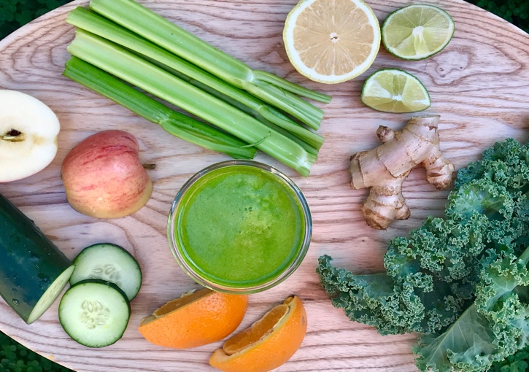

Cleanse Smoothie
1 ½ cups nondairy milk or water
1 cup mixed greens
2 kale leaves
½ avocado
1 orange
8 drops of Wild Orange essential oil
1 tablespoon ground flax seeds
dash of cayenne

LUNCH-

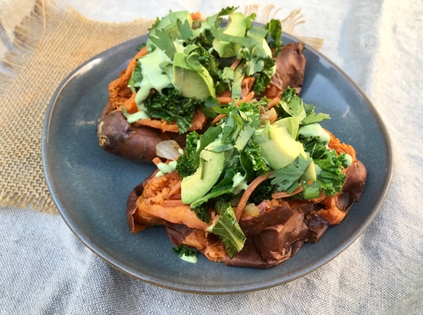

Green Stuffed Sweet Potatoes
Serves 2
1 teaspoon coconut oil
1 small onion, chopped
1 bunch kale (any variety), chopped
1 large carrot, shredded
sea salt and black pepper to taste
2 baked sweet potatoes (see Recipe Basics)
1 avocado
½ bunch cilantro, chopped
Orange Vinaigrette

Melt coconut oil in a sauté pan over medium heat. When the oil is melted, add chopped onion. Sauté for about 3 minutes until fragrant, then add chopped kale. Sauté for an additional 3 minutes, then add shredded carrot. Sauté for an additional 5 minutes until the kale is tender. Serve kale over a warm sweet potato topped with avocado, cilantro, and orange vinaigrette dressing. Add a protein of your choice, if desired.

Orange Vinaigrette

juice of 2 large oranges
10 drops of Wild Orange essential oil
1 garlic clove, finely chopped
1 tablespoon honey
1 tablespoon apple cider vinegar
2 tablespoons extra virgin olive oil
sea salt and black pepper to taste
Combine all ingredients in a bowl or closed jar. Whisk with a fork--or shake if using a jar--until well incorporated. Store in the refrigerator

DINNER-

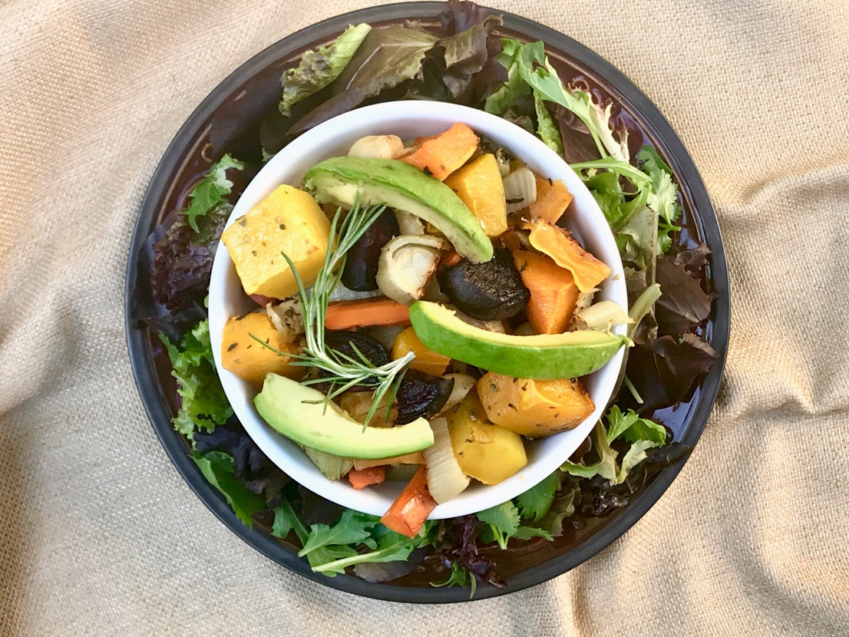

Italian Roasted Vegetables with Salad
Serves 4
2 large beets, chopped
1 large fennel, chopped
1 cup butternut squash
1 large carrot
1 large onion
1 head of garlic, separated and paper removed
1 tablespoon Italian seasoning
avocado
sea salt and black pepper to taste

Preheat oven to 400 degrees F.

Combine all ingredients in a large mixing bowl. Mix well and spread on a shallow baking sheet. Bake for about 30 to 40 minutes or until all the vegetables are tender and golden brown along the edges. Remove from heat and set to the side to cool for about 15 minutes. Serve vegetables warm or cold with a large salad and sliced avocado. Add your choice of protein.

DAY 2

BREAKFAST-

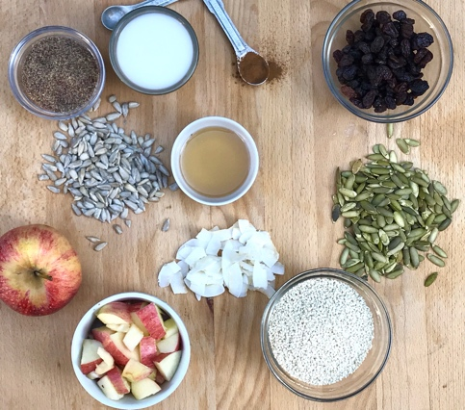

Boundless Energy Seed Cereal
Serves 1
1 handful raw pumpkin seeds
1 handful raw sunflower seeds
1 handful sesame seeds
1 tablespoon ground flax seeds
1 tablespoon unsweetened coconut flakes
1 handful raisins
1 apple, chopped
1 teaspoon cinnamon
1 cup nondairy milk
1 tablespoon maple syrup
1 drop of On Guard essential oil

Combine all ingredients in a cereal bowl. Mix well and serve.

LUNCH-

Massaged Kale Salad
Serves 2
1 bunch kale, chopped (any variety)
1 avocado
juice of 1 lemon
sea salt and black pepper to taste
1 beet, shredded

Place chopped kale in a large salad bowl. Top with avocado, lemon juice, sea salt and black pepper. Use your hands to massage the mixture until the kale is tender and wilted. The avocado and lemon juice should coat the kale to make a salad dressing. Top with shredded beets and your choice of protein.

DINNER-

Sweet Potato Mash Bowl

Serves 4
4 large baked sweet potatoes (see Recipe Basics)
1 teaspoon pumpkin pie spice
1 tablespoon coconut oil
4 cups mixed greens
2 apples, chopped
1 small red onion, chopped
1 avocado
1 tablespoon sesame seeds
Orange Vinaigrette

Remove the skin off the sweet potatoes. Mash the remaining sweet potato in a mixing bowl with pumpkin pie spice and coconut oil. Top with mixed greens, chopped apple, chopped onion, avocado, sesame seeds, and Orange Vinaigrette. Serve with your choice of protein.

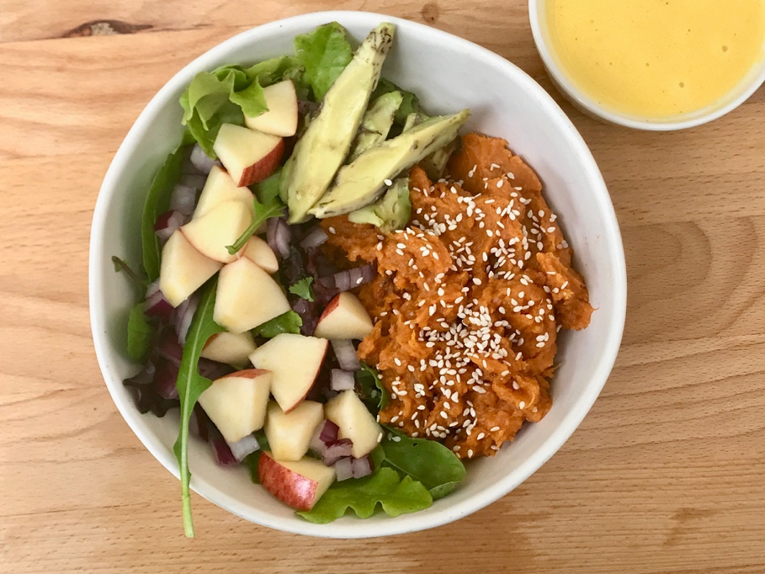

2018 Wendy Patrucco
These statements have not been evaluated by the Food and Drug Administration.
This is not intended to diagnose, treat, cure, or prevent any disease.

Shopping List-

Essential oils; On Guard, Lemon, Wild Orange
Braggs raw apple cider vinegar
Sweetener; honey, maple syrup or stevia
Non-dairy milk
5 c. Mixed greens
2 bunches of kale
3 oranges
Fractionated Coconut Oil
2 yellow onions
1 sm. Red onion
1 lemon
Pumpkin Pie Spice
2 lg. carrots
6 sweet potatoes
4 avocados
Cilantro
Garlic
Extra Virgin Olive Oil
3 beets
1 lg. fennel
1 cup cubed butternut squash
Italian seasoning
Raw pumpkin seeds
Raw sunflower seeds
Sesame seeds
Unsweetened coconut flakes
Raisins
3 apples
cinnamon

